5321 Homework 3

Summer 2020

Question Weighting:

Question 1- 5 - 20 % credit each - total 100% credit

Use the EBP approach for each problem.

1. Develop CFG (reduced) and Cyclomatic complexity.
2. Develop basis path set.
3. Determine significance on each variable.
4. Add tests for missing Boundary Values not tested, including extreme range values - extreme range values for EACH variable that has a boundary condition in the code.
5. For basis path use the all true path as the first test case.

Submittal items, **for each problem** ***submit*** the following and number them accordingly

1. Code description
   1. For problems 1, 2, and 4 use a decision table. Use slide 61 of M03 as a guide for the decision table format.
   2. For problem 3 use a logical expression
   3. For problem 5 draw a graph (can be drawn by hand and scanned in). Make sure axes are labeled with values at each whole number
2. CFG (reduced) - can be hand drawn and scanned
3. Cyclomatic Complexity (indicate on the graph)
4. Test case table with basis paths (put these in the "Basis Path" column. Where tests are addition to basis path set use a "-" in the basis path column. Make sure all true is the first BP.
5. Code coverage achieved
6. Test cases support or refute description?

Assume:

1. a significance of 1 Cent on financial calculations
2. Assume 0.1 on all doubles, unless otherwise specified.
3. Use Excel's default of rounding to the significance. For financial display $0.00 and doubles 0.0 except as otherwise indicated - this will implicitly round to the significance.

Proper application of the CFG to the basis path

1. **Start at the upper left and work toward the lower right of the CFG flipping decisions from upper left toward lower right. Make sure to put nodes at subsequent levels on the CFG. See slides 41-44 of M09**

1) Use basis path testing to develop the test cases for the following code. Use the line (statement) numbers below in your CFG. AGL ranges from 0.0 to 10,000.0 feet both inclusive with 0.1 feet of significance.

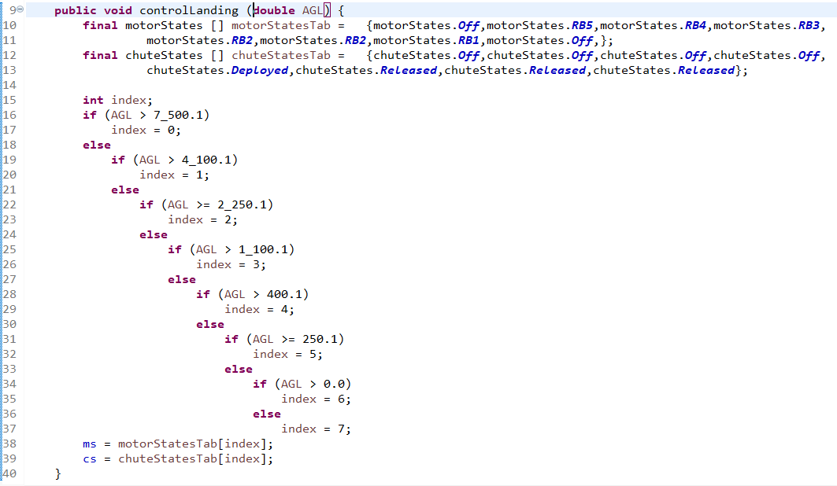

Test case table format:



**SOLUTION**

1. Code description - the decision table follows.



Table must

1. Mention units (feet)
2. show thousand separators
3. show significance
4. only use relational operators of inclusion (where possible)
5. state first-of rule

2. and 3. CFG and Cyclomatic Complexity follow



ECP/BV follows (**THIS IS NOT REQUIRED**)

4. Test Case Table (note that in the attached Excel file I use VB to determine the expected outputs - this is not required by the students)



Note: the first 8 test cases MUST be in this order

5. Code coverage achieved is: Decision coverage, Statement coverage, Full BV coverage, and Extreme Range coverage.

6. Yes

2) Use basis path testing to develop the test cases for the following code. Use the line (statement) numbers below in your CFG. Assume batteryLevel ranges from 0.0 to 1,000.0 watts both inclusive.

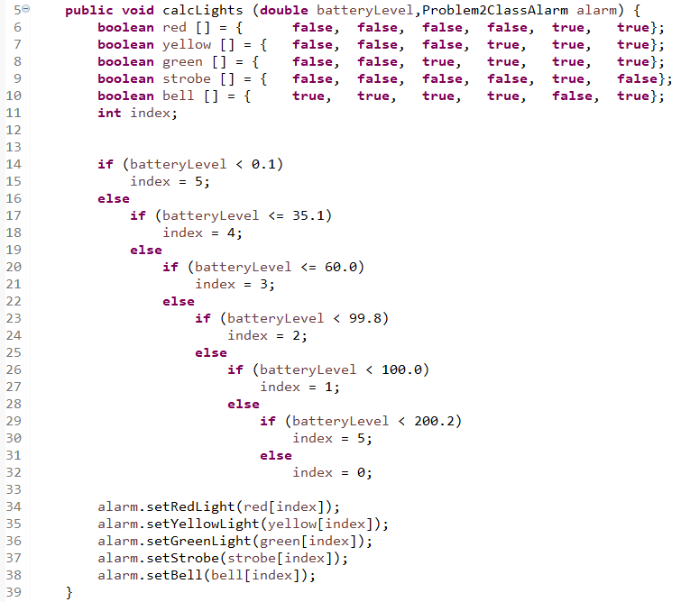

Test case table format:



**SOLUTION**

1. Code description - the decision table follows.



Table must

1. Mention units (watts)
2. show thousand separators
3. show significance
4. only use relational operators of inclusion (where possible)
5. state first-of rule
6. highlighting is NOT required

2. and 3. CFG and Cyclomatic Complexity follow



ECP/BV follows (**THIS IS NOT REQUIRED**)



4. Test Case Table



Note: the first 7 test cases MUST be in this order. Significance must be shown and thousand separators must be used.

5. Code coverage achieved is: Decision coverage, Statement coverage, Full BV coverage, and Extreme Range coverage.

6. Yes

3) Use basis path testing to develop the test cases for the following code. Use the line (statement) numbers below in your CFG. Assume that total ranges from $0.00 to $20,000.00 and memberPoints from 0 to 9,999 all inclusive.

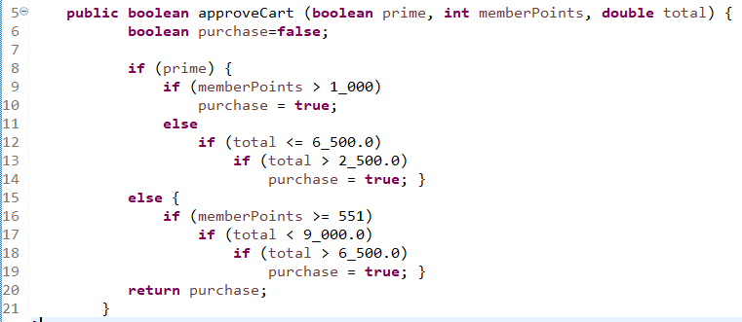

Test case table format



Mentally transform statements 9-14 and 16-19 into a multiple condition decision statement as described in slides 41-52 of M09 and show the MCDC test cases for this logical expression in the test case table.

**SOLUTION**

1. Code description - the logical expression follows.

purchase (or return) = prime (memberPoints>1,000.0 + (total <=6,500.0)(total > 2,500.0)) +

prime'(memberPoints>=551)(total<9,000.0)(total>6,500.0)

or this could be written in code style as

purchase (or return) = prime && (memberPoints > 1_000.0 || total <= 6_500.0 && total > 2_500.0) ||

!prime && memberPoints >= 551 && total < 9_000.0 && total > 6_500.0;

2. and 3. CFG and Cyclomatic Complexity follow



ECP/BV follows (**THIS IS NOT REQUIRED**)



4. Test Case Table



Note:

1. the first 8 test cases MUST be in this order.
2. MCDC test cases must be indicated as shown
3. $ currency must be shown for total
4. Significance must be shown for both memberPoints and total
5. Thousand separators must be used.
6. Yellow indicates don't care values above for extreme range tests

5. Code coverage achieved is: Decision coverage, Statement coverage, Full BV coverage, and Extreme Range coverage.

6. Yes

4) Use basis path testing to develop the test cases for the following code. Use the line (statement) numbers below in your CFG. Assume that temperature ranges from 0 to 500 degrees F, pressure from 0.0 to 10,000 psi all inclusive and both with a significance of 0.1

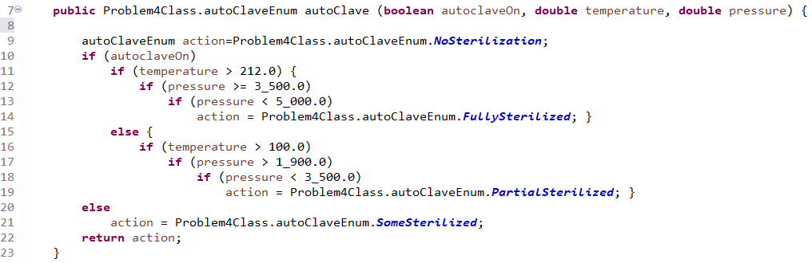

Test case table format:



Mentally transform statements 10-13 and 15-18 into multiple condition decision statement as described in slides 41-52 of M09 and show the MCDC test cases for this logical expression in the test case table.

**SOLUTION**

1. Code description - the decision table follows.



Table must

1. Mention units (psi AND degrees F)
2. show thousand separators
3. show significance
4. only use relational operators of inclusion
5. state first-of rule

2. and 3. CFG and Cyclomatic Complexity follow



ECP/BV follows (**THIS IS NOT REQUIRED**)



4. Test Case Table (note that in the attached Excel file I use VB to determine the expected outputs - this is not required by the students)



Note:

1. the first 9 test cases MUST be in this order.
2. Significance must be shown
3. Thousand separators must be used.
4. Yellow indicates don't care values above for extreme range tests

5. Code coverage achieved is: Decision coverage, Statement coverage, Full BV coverage, and Extreme Range coverage.

6. Yes

5) Use basis path testing to develop the test cases for the following code. Use the line (statement) numbers below in your CFG. Assume that x ranges from -2.00 to 10.00 both inclusive. Assume both y and y are significant to 0.01 (use Excel's answer without truncation which means it will round to the 0.01).

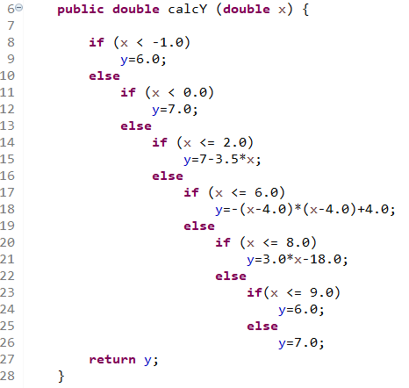

Add tests as follows:

1. For each linear region, in the middle of the ECP.
2. For each parabolic - at the max/min and mid-range (mid-range of x) on one side of the max/min. (2 tests total).

**Submit the graph with your solution. Develop your tests using the graph. You may hand draw the graph and scan BUT IT MUST BE GRADEABLE. You must label the axes and show values across each axis at each whole number.**

Test Case table format



**SOLUTION**

1. Code description - the graph follows.



Graph must

1. Label both axes
2. Show significance on both x and y axes
3. Show labels at whole number as shown
4. show the shape above with high quality lines

2. and 3. CFG and Cyclomatic Complexity follow



ECP/BV follows (**THIS IS NOT REQUIRED**)

x values:

4. Test Case Table (note that in the attached Excel file I use VB to determine the expected outputs - this is not required by the students)



Note:

1. the first 7 test cases MUST be in this order.
2. Significance must be shown

5. Code coverage achieved is: Decision coverage, Statement coverage, Full BV coverage, and Extreme Range coverage.

6. Yes